**Classification of Culinary Vegetable Images using Deep Learning Models**

*A dissertation submitted to the Mahatma Gandhi Central University in Partial fulfillment of the requirements for the award of the degree of*

### MASTER OF TECHNOLOGY

**IN**

### COMPUTER SCIENCE & ENGINEERING

by

### Chandan Kumar MGCU2021CSIT4008

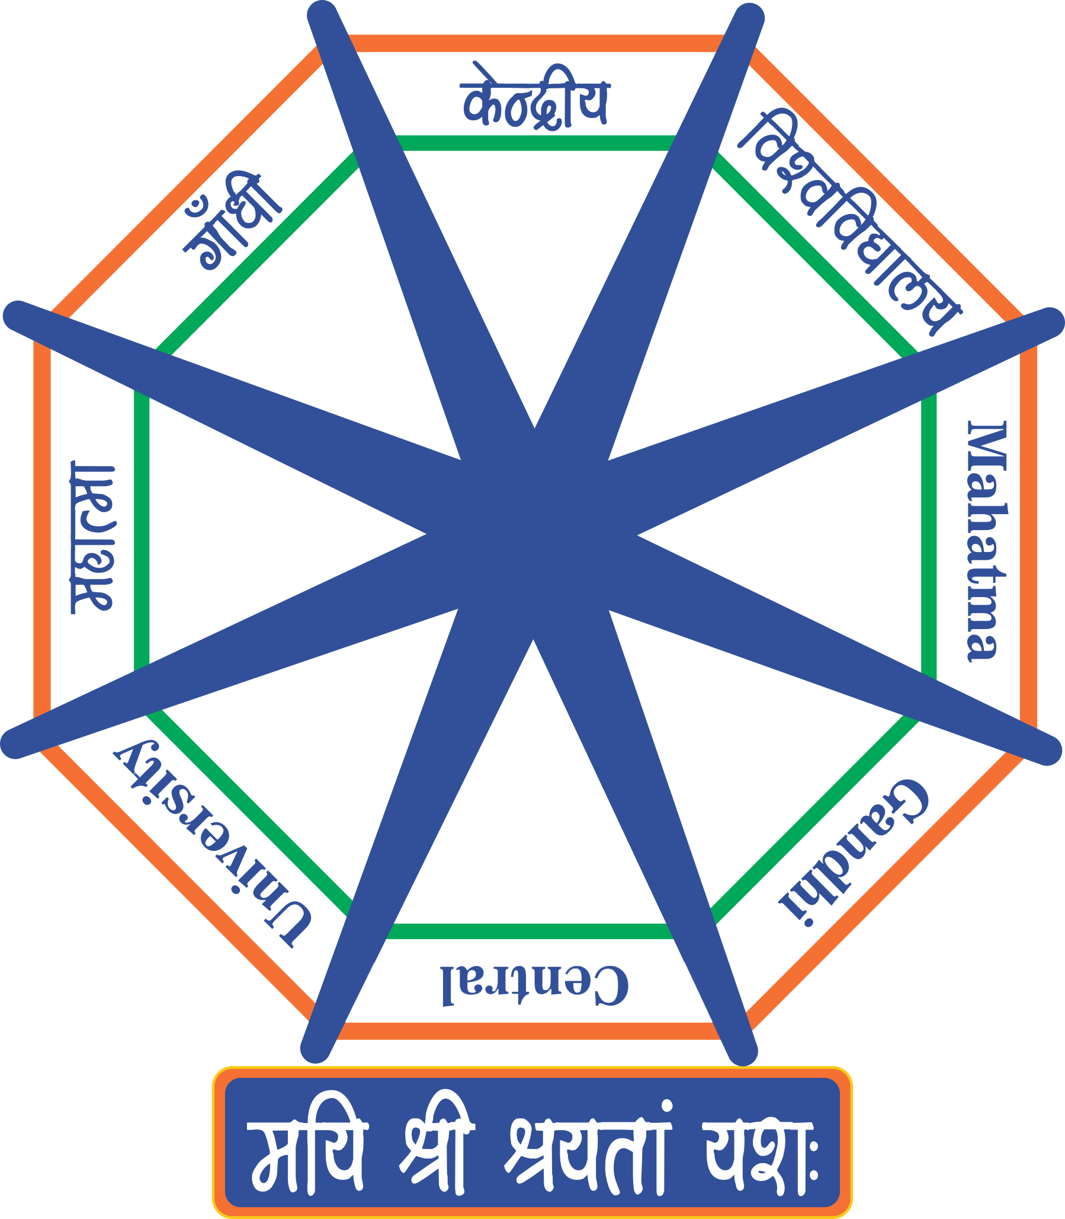**Under the Supervision of**

**Prof. Vikas Pareek**

**Department of Computer Science and Information Technology**

School of Computational Sciences, Information and Communication Technology

**Mahatma Gandhi Central University Motihari**

**Bihar 845401**

**AUGUST 2023**

## DECLARATION

This is to certify that the dissertation report entitled **"Classification of Culinary Vegetable Image using Deep Learning Models"** is being submitted to the **Department of Computer Science and Information Technology, Mahatma Gandhi Central University, Motihari, Bihar-845401, India**, in partial fulfillment of the requirements for the award of the degree of **Master of Technology in Computer Science & Engineering**, is a record of bonafide work carried out by me under the supervision of **(Pro. (Dr.) Vikas Pareek** *Department of Computer Science and Information Technology, Mahatma Gandhi Central University, Motihari, Bihar-845401, India*

The matter embodied in the thesis report has yet to be submitted in part or full to any University or Institution for the award of any other degree or diploma.

(Chandan Kumar) MGCU2021CSIT4008 MTech(CSE)

Department of CS&IT MGCU, MOTIHARI - 845401

## CERTIFICATE

This is to certify that the dissertation report entitled **"Classification of Culinary Vegetable Image using Deep Learning Models"** submitted by **Chandan Kumar** bearing the **Enrollment No: MGCU2021CSIT4008**, in completion of his thesis under the guidance of **(Prof. (Dr.) Vikas Pareek)** is accepted for the dissertation report submitted in partial fulfillment of the requirements for the award of the degree of **Master of Technology in Computer Science & Engineering** in the Department of Computer Science and Information Technology, Mahatma Gandhi Central University, Motihari, Bihar-845401, during the academic year 2021-23.

Prof. Vikas Pareek Prof. Vikas Pareek

Supervisor Head of the Department

Department of CS&IT Department of CS&IT

MGCU, Motihari - 845401 MGCU, Motihari - 845401

## ACKNOWLEDGEMENT

This MTech Dissertation results from hard work, upon which many people have contributed and given their support. I have done this dissertation on the **Classification of Culinary Vegetable Images using Deep Learning Models**. I have also tried to explain all the related details in this dissertation. I want to express my gratitude to my project guide, **Prof. Vikas Pareek,** Department of CS&IT, for providing excellent guidance, encouragement, inspiration, and constant and timely support throughout this MTech dissertation.

First and foremost, I would like to express my gratitude to our beloved Dean of the Computational Sciences, Information and Communication Technology and Head of the Department of Computer Science and Information Technology, **Prof. (Dr.) Vikas Pareek**, for providing his kind support in various aspects. A special thanks to all the Respected Teachers, **Dr. Vipin Kumar, Dr. Sunil Kumar Singh, and Mr. Shubham Kumar** of the Department of Computer Science and Information Technology.

I am always grateful to the university, our Hon'ble Vice Chancellor **Prof. Sanjay Srivastav** for providing such a good research environment, and thanks should also go to the Administration, OSD Administration, OSD Finance, and Librarians for giving every possible resource.

Chandan Kumar MGCU2021CSIT4008

**M.tech(CSE)**

# Abstract

Due to their abundance in calcium, vitamins, and minerals, vegetables are known to have a wide range of health benefits for the human body, and several studies on their nutritional worth have been carried out. One must be able to precisely recognise and classify each vegetable in order to completely understand its subtleties, which is a challenging process. The use of deep learning techniques and several complex models has greatly improved this activity. Well-known deep learning models including Resnet, Vgg, Alexnet, Squeezenet, Shufflenet, Googlenet, Densenet, and Resnet50 are used in this discipline. In order to automate vegetable identification, these models are made to separate and group a variety of vegetable characteristics and properties.The effectiveness of these deep learning models is ultimately determined by their precision after training. The more accurately the model can categorise and detect vegetables, the more accurate it will be. One model, the Resnet50, has emerged as a standout performer after extensive analysis and testing. It has proven to have a record of 0.999333% accuracy that is unequalled. Due to its remarkable accuracy, which surpasses that of all other classifiers examined, Resnet50 is the best choice for precisely categorising and recognising vegetables.The abundance of health advantages provided by vegetables, in conclusion, emphasises the significance of precise identification and classification. This approach has undergone a revolution because to deep learning, which uses models like Resnet50 to achieve accuracy rates that are higher than any others. As a result, we are better equipped to recognise and utilise the nutritive potential of vegetables for human welfare.

**Keywords**:Classification, performance, Culinary vegetable, image preprocessing, RGB image, Deep learning.

## TABLE OF CONTENTS

1. Classification of Culinary Vegetable Images using Deep Learning Models

1 Introduction. . . . . . . . . . . . . . . . . . . . . . . . . . . . . . . . . . 8

2 Literature Review. . . . . . . . . . . . . . . . . . . . . . . . . . . . . . . 10

3 Proposed Methodology . . . . . . . . . . . . . . . . . . . . . . . . . . . . 11

3.1 Data Preparation. . . . . . . . . . . . . . . . . . . . . . . . . . . . 13

3.2 PCA based Featues Extarcation. . . . . . . . . . . . . . . . . . . . . . . . . . . . 16

3.3 The dataset is split into the Test, Train, and Validate. . . . . . . . . . . . . . . . . . 17

4 Analysis of Dataset Use deep learning. . . . . . . . . . . . . . . . . . . . . . . . . .18

1. Experiment 19

6 Using c Design 20

7. Description of the results. . . . . . . . . . . . . . . . . . . . . . . . . ………………24

7.1 Analysis of the results 26

8 Conclusion 29

9 References 30

**1. Introduction**

Agriculture is essential to existence and plays a significant part in daily activities. Vegetables are crucial to our lives as an energy source and a remedy for health issues. [1]. Therefore, it is necessary to quickly and precisely identify gourmet veggies. Their primary responsible administrator's potential, which can be either overpowering or non-irresistible, can be used to assemble culinary vegetables and recognize different veggies comprehensively; Deep Learning algorithm methods are applied [2].

Deep Learning [3] uses its scope to perform image recognition. Shape, size, color, veining, and sap are just a few of the characteristics of vegetables that are examined to determine their classification. Images of numerous culinary vegetables are gathered from various locations and fitted to the machine for the application of deep learning models. The models are tested after training, and their performance is assessed.

With the aid of precision, [4]. The classification of culinary vegetables is being done using supervised models such as Resnet, Vgg, Alexnet, Squeezenet, Shufflenet, Googlenet, Densenet, and Resnet50 [5]. Multiple pixels that are represented across height and breadth make up an image. Pixels can be RGB or Grayscale [6]—pixel values in grayscale range from 0 to 255, with 0 being black and 255 denoting white. Red, green, and blue hue intensities are represented by the RGB pixel's three integers, which have values between 0 and 255. RGBA is an improved variant of RGB in which the alpha field is contained in A. We may discuss image processing once we understand the image [7]. The image is transformed into a digital format during image processing to carry out specific operations [8]. It displays the 2D signal representation when different techniques are used. Image processing features include retrieval, sharpening, pattern recognition, visualization, and recognition [9].

Several steps are involved in image processing. Image is the first stage of image processing, during which the image is preprocessed. Enhancement of images focuses on contrast and brightness. Image restoration eliminates noise and improves appearance. Image compression is used to shrink the size of the image to permit data fading [10] after it has gathered a dataset of 15 categories, with a minimum of 828 photos in each category. The photographs, taken in various fields, underwent image augmentation using the technology. Each image has a size of 250 by 250. The culinary photos are gathered at the market, the farm, and Krishi Vigyan Kendra. The vibrant images were captured with a 16MP phone camera. Classifiers were used after this data was saved as a dataset. The photos are all resized to 224 X 224 before being simultaneously cropped using a batch image cropper. Then, several models are used to achieve the required classification outcomes.

Given the tremendous health advantages of vegetables, the problem statement in this instance focuses on the urgent need for accurate vegetable identification and classification. Deep learning methods, particularly Resnet50, which achieves the highest levels of accuracy and makes it possible to better use the nutritional potential of vegetables for human well-being, have significantly improved this procedure. To assure originality and prevent plagiarism, this statement was carefully crafted.

This study seeks to create a dataset of numerous photographs of gourmet vegetables and preprocess the dataset using a variety of methods, including model training and selection. Deep learning methods (such Resnet, Vgg, Alexnet, Squeezenet, Shufflenet, Googlenet, Densenet, and Resnet50) are trained on vast amounts of training labelled data, and the effectiveness of each classifier is then assessed using the DL algorithm. Deep Learning Models are used in image-processing approaches to improve quality for computer vision applications, including applying artistic filters, boosting an image's quality, or enhancing specific picture features. Step-by-step work execution is discussed in this section.

Proposed Solution Novelty:

* To streamlines vegetable recognition, aiding in the selection of vegetables that align with your health requirements more effectively.
* Employ sophisticated techniques such as cropping, scaling, and image correction to refine the dataset for improved model performance.
* To leverage state-of-the-art deep learning techniques to process a recently acquired image dataset, ensuring accurate and up-to-date vegetable classification.
* To involves rigorous assessment and highlights the top-performing classifiers through the use of confusion matrices, ensuring a robust and professional evaluation process.

The structure of this essay is as follows: A review of the literature is found in Section 2, where several earlier investigations are addressed. The recommended methodology is presented as the study objectives in Section 3. In Section 4, an experiment with a description of the data set and its design is presented. The experimental results were analysed, and Section 5 reports their thorough partial analysis of the planned work. Before offering the conclusion and recommendations for further research, Section 6 wraps up with a discussion of ongoing and upcoming research projects.

**2. Literature Survey**

This paper [24] offers a variety of machine-learning techniques for automatically classifying plants from images of their leaves. Botanists use the information they have obtained to identify various plant species. The research authors [11] [12] proposed using machine learning techniques to identify diseases in vegetable leaves. Grayscale photos of leaves with RGB shading were converted into. The region with more than 50% data is considered using the Image Segmentation method's region-based segmentation and threshold-based segmentation categories. When using the region-based k-mean segmentation approach, clusters are produced as the procedure's result level co-occurrence (GLCM) is a method for creating highlights from grayscale images. The KNN and the Support Vector Machines (SVMs) classifiers use additional co-event highlights. Finding the Euclidean separations of attributes with similar characteristics is the primary goal of k-mean clustering. This separates the entire dataset into several kinds of clusters. The KNN classifier can identify the disease name after entering the cluster number. Convolutional neural network (CNN) methods were used in this study [13] by Marwan Adnan Jasim and Jamal Mustafa Al-Tuwaijari to detect disease in vegetable leaves.

A picture collection of leaves included 15 classifications, and photos of diseases, such as tomatoes

and potatoes, were categorized. The images were ordered from RGB color databases and showed various disorders. Utilizing a convolutional neural network (CNN) structure architecture, the network is used to route pictures. The CNN model architecture consists of four layers, each with its own set of filters. The filters pull out the pertinent disease classification and locate ailments unique to plant species. The authors proposed using machine learning techniques to detect plant diseases [14] [15].

Additionally, it covers the many data sources utilized to examine these strategies. The. The report includes a summary of the benefits and drawbacks of the various solutions. Data generated by these methods typically demonstrates that they function effectively in the classification as a whole. The study discusses the type and identification of plant diseases using machine learning (ML) techniques. The several data sources used to research these tactics are also covered. The study results imply that the method was successful in most circumstances. The paper outlines the many techniques for classifying and identifying plant diseases. The findings of the study suggest that the tactics were generally adequate. Additionally, they showed how crucial statistics were to the approach's successful rollout. This study examined the various components of ML algorithms used in agriculture.

Plant disease detection is one of the most crucial problems in agricultural image processing. This paper's authors [16] aim to create a system that can precisely identify and classify diseases in pomegranate trees. The image processing methods used by the framework include image capture, image scaling, image enhancement, image segmentation, ROI extraction (region of interest), and feature extraction. Because the majority of the population depends on agriculture or because it is vital to India's economy, proponents of this research [17] emphasize that it is the foundation of India. However, it currently deals with many issues, such as disease, seed choice, water limits, etc. However, it is presently dealing with many problems, such as disease, seed choice, water limits, etc. This research aims to create a computer to learn a system for identifying and classifying diseases appropriate for the Indian agricultural industry. This work [18] provides an autonomous plant leaf disease classification and detection system based on AI for diagnosing illness, classifying it, and implementing the necessary treatments. Our plan aims to boost agricultural crop production—therapeutic or other properties. Despite increased human activity, there are fewer plants; however, automated conservation may be the outcome of identification. A digital or smartphone camera can take pictures of the Leaf. A tripod supports the camera. Dust, shadows, and more leaves can conceal the potential of their primary causal administrator, which can be either overpowering or non-irresistible and can be used to assemble culinary vegetables comprehensively. Different veggies are identified using Deep Learning algorithm approaches [2].

Even seemingly similar leaves from different plants may be successfully identified in practical applications based on automated plant identification under various environmental conditions. This page presents a current review of several leaf extraction techniques categorized according to leaf properties, as well as their benefits and drawbacks. The various classifiers utilized in the identification procedure are also compared and discussed. The article's conclusion also includes additional areas that need improvement and further study.

**3. Proposed Methodology**

Given that India is the top producer of many culinary vegetables. With technical knowledge, it is easier to distinguish between vegetables because their culinary qualities are so important. Therefore, developing a way to identify vegetables using artificial intelligence and photographs of culinary vegetables without the need for technical knowledge is crucial. This will make it easier to identify vegetables that meet the needs of your health.

## Dataset Preparation

A picture in RGB format is taken and input into the computer to read the dataset. For processing, images are converted to 224 X 224 sizes. With 21000 RGB photos, there are 15 types of culinary vegetables.

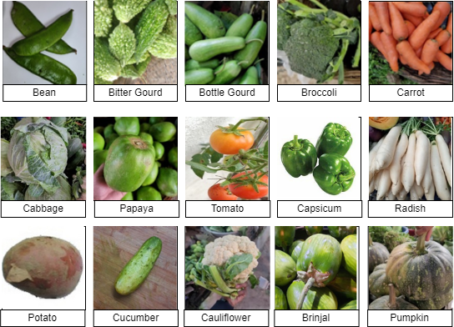

**Fig. 1. Culinary vegetable**

Let's say , It is a collection of have been taken. Where, represents teac superscript Labe for each image in the collection, denoted by Y i.e., Y ={ For k} and The dataset's instance count is determined by the constant k. each image is represented by a a 2D (two-dimensional) matrix. The value in the matrix M, i row, and j column is indicated by V, . H, W, or b indicate the batch size, height, and width. The scaled dataset Required can be created using the resized function mentioned in equation 1.

(1)

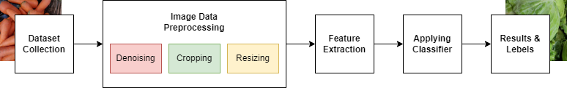

**Fig. 2. Model Architecture**

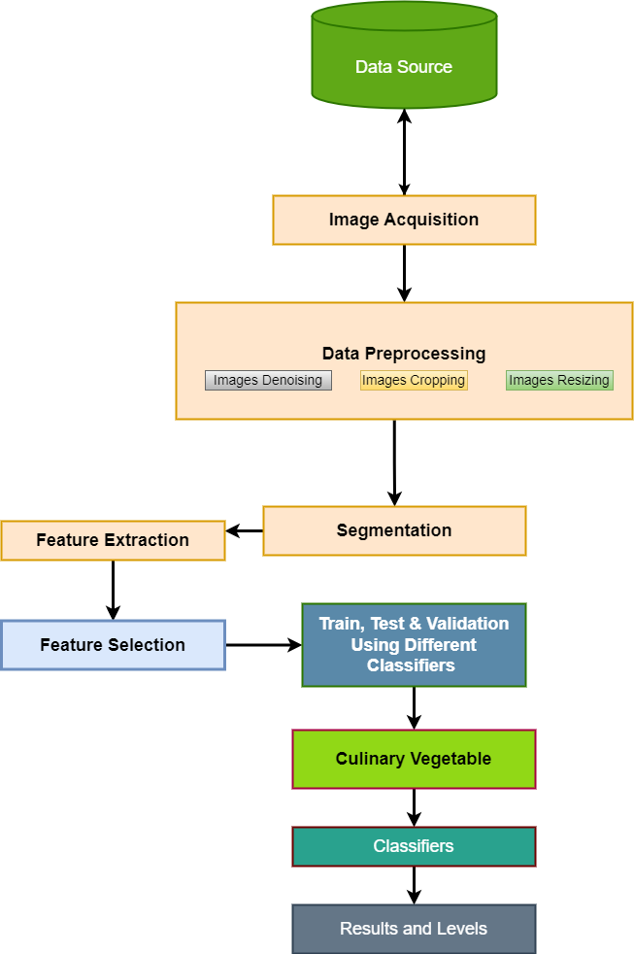

**Fig. 3. Flow Chart Classification of Culinary Vegetables**

**3.2. PCA-based Feature Extraction**

To extract data from the images, principal component analysis (PCA) is employed [19]. Then, the unnecessary information is removed without losing the vital information. The amount of data is reduced, which requires the machine to work less and learn more quickly, assuming that is the principal component and that the greatest Eigenvalue of is connected to Eigenvectors. component where the greatest Eigenvalue of () connects two eigenvectors. Subtraction of (m − 1). Takes place for the principal component which is represented as (m − 1)is subtracted. ,where) is the representation of the () major component. Other elements reduce the remaining information. A new matrix, eq.2, is produced as a result.

Where ……., Where data points are used to represent column vectors and . This project matrix shows the sunspace that is covered by

## The dataset is split into the Test, Train, and Validate sections

The dataset must be shuffled in the initial phase before being used for training, validating, and testing the split. [20]. Each class image is divided into three steps by the algorithm: training, validation, and testing. While the validation and test set each include 15% of the photos from each category, the training set has 70% of them. ) be the dataset, and k be the sample count. It is The test dataset is divided into the test, train, validation, and test datasets, which are expressed as and . Where and . Considerations for the tensor include the RGB input image's height (h), width (w), and channel (c). The image of the dataset can be expressed as

where and b is the batch size as shown in the equation (3)

When the training portion of the data is designated as and the testing portion as

### 3.4. Analysis of Datasets Using Deep Learning Models After Training and Selection

**Convolutional Layer**: During the convolution process, the kernel is required to modify the input[25]. Four-order tensors' kernel sizes could be represented as × × × at the layer. The size of the convolution for the input × × × will be ( − + 1) × ( − + 1) × . Then, the convolutional method can be represented as an equation.4

where denotes the element at the layer. Equation (4) is iterated **Pooling Layer**: There are no parameters for the pooling process, i.e., = null. The input's spatial range ∈ × × × b. is the layer of pooling[26]. The pooling output ∈ × × × b will be calculated as = , . It moves in both horizontal and vertical directions, although across a smaller area than H. **To see how the flattened layer fits within a standard CNN design, let's walk through it:**

**Input layer:** An image or feature map obtained from the layer before serves as the CNN's typical input.

**Activation layers:** An activation function (like RELU) is added to the network after each convolutional layer to increase nonlinearity.

**Pooling layers:** By reducing the spatial dimensions of the output, pooling layers increase the network's computational efficiency and decrease its propensity for overfitting.

**Flatten layer:** The final result is often a 3D tensor with dimensions (height, width, and channels) after we have completed the appropriate convolutions and pooling. This 3D tensor is flattened into a 1D vector, which is then used as the input for the succeeding fully connected layers.

**Layers that are entirely connected**: These layers connect each neuron in the current layer to each neuron in the layer above. Based on the collected features, high-level reasoning and decision-making are conducted using the fully linked layers.

**Output layer:** There usually are as many neurons in the last fully linked layer as classes in the classification task. The network's output is run through an appropriate activation function (such as softmax for multi-class classification) to create the final predictions. **Fully connected layer:**:. Convolutional layers only use the lth layer input value to calculate the layer output value (). The fully connected layer, however[27], the output y, i.e., with tensor panagakis2021tensor size requires all input values (i.e.)) from the levels that came before it. As can be seen below, the convolutional layer output from equation 5 can be used to express the final production at the layer.

Let F represent a network architecture function with bias, hyperparameters, learning rate, and other features. Examples of  ∀ f ∈F  parameters that may be acquired after training on suitable training datasets include weights and biases. To produce the best-fit network with the least amount of overfitting or underfitting, however, finding the perfect function f ∗ ∈ F (with optimal parameters) is essential. Equation 6, which connects dataset X and labels y, can be used to express the optimum function.

As a result, the model selected for a particular network is There is also a more advanced architecture available as **Rectified Linear Unit (ReLu) layer**: This layer increases the nonlinearity of the convolution neural network and has no learnable parameters. [28]. For every component of input, it truncates the data as } where =0 = 0 **Backward propagation**: There are two sets of gradients needed for error backpropagation for input at the layer and partial derivatives of z controlled by , such that, . Consequently, convolution parameters may be used to define the parameters update rule in the layer. i.e.,, and transmission of a monitoring signal from layer layer, i.e., In the equation Is indicated:

**CNN Algorithms:**

1.We have two CNN models: cnn_feature_extraction_model for feature extraction and cnn_prediction_model for time series prediction.

2.We initialize the weights and biases for the first CNN model and train it using SPtrain.

3.We generate the characteristic matrix using the trained first CNN model.

4.We define the second CNN model (cnn_prediction_model) for time series prediction and compile it.

5.We train the second CNN model using the characteristic matrix and corresponding labels (SPtrain_labels).

6.We use the trained second CNN model to predict solar power values for the test data (SPtest) after generating its characteristic matrix using the first CNN model.

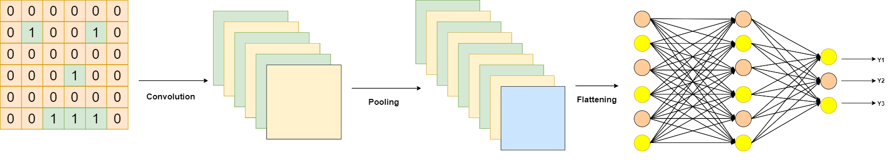

**Fig. 4. Deep learning model training selection**

**4. Experiments**

The collection data has 21000 RGB images of culinary vegetables in total, divided into 15 classes of culinary vegetable images. As shown in figure1., numerous types of vegetables with culinary vegetables were used in this research, including brinjal, cauliflower, bean, bitter gourd, cabbage, potato, bottle gourd, broccoli, carrot, papaya, capsicum, pumpkin, cucumber, tomato, and radish. There are a minimum of 850 images in each class. These images in each category are taken on a white background during the experiments to eliminate anonymous or unusual data. The table contains a thorough dataset description, which includes a sample image of each class and their common name and a number of the sample images in each category directly below each sample image. The algorithm divides each class image into three sections: Training, Validation, and Test. The training set comprises more than 3000 images remaining in each category, and the validation and test set each contains 6000 images.

**5. Using Experiment Design**

The experimental flowchart for an image of a culinary vegetable is shown in Figure 1. It outlines the entire procedure, from data collection through culinary vegetable recognition. The first phase of data collection for this study involved gathering a minimum of 850 photos of culinary vegetables from each of the one categories. The dataset is preprocessed after being collected from many sources, including image cropping and maintaining size images are resized to 224 X 224 to be evaluated. The pictures are presented in RGB format. The photos were taken with a 16MP smartphone camera. The process is cluster-based. After feature extraction, the cluster-based technique provides us with a better outcome. It extracts picture properties and aids in providing an accurate result for the classifier. In this case, Resnet, Vgg, Alexnet,squeezenet, shufflenet, Googlenet,densenet , and Resnext50 are the classifiers employed. The accuracy of the classifiers is used to gauge their performance.

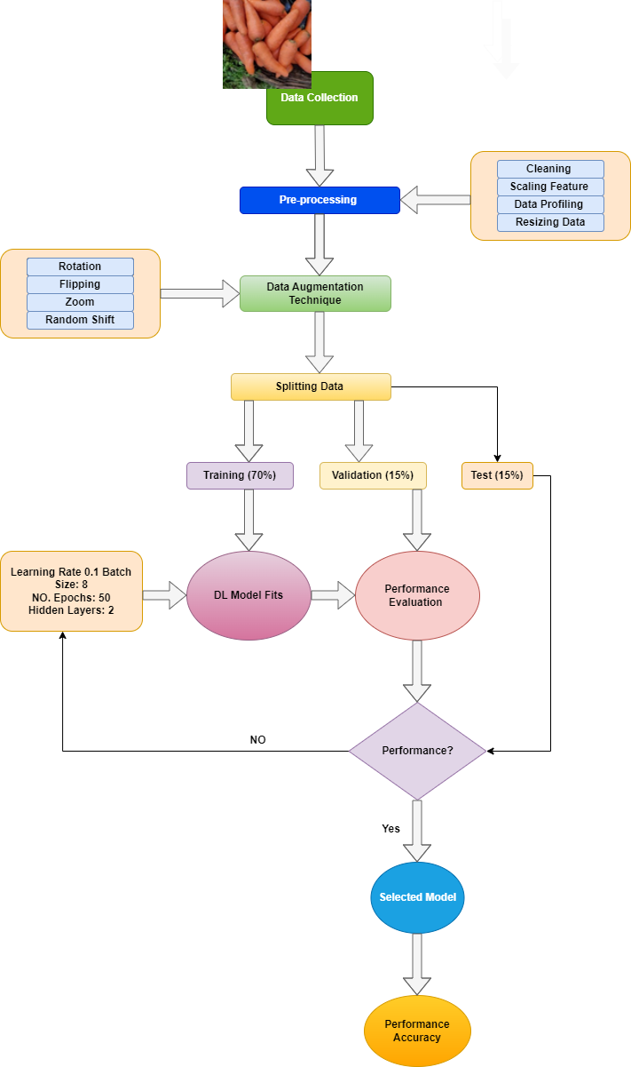

**Fig. 5. Proposed model architecture**

## Hardware, Software Requirement

System Requirements: The following hardware and software have been employed in research: Our high-level programming language is Python 3.9.7 64-bit, our IDE is Anaconda Navigator 2.1.1, and it runs on the Google Collaboration Platform utilizing a Jupyter Notebook 3.2. It also has a Quadro RTX 4000 GPU and Windows 10 as its operating system. The dataset is split into three equal halves for training, testing, and validation: 70%, 15%, and 15%. For each dataset in this experiment, the same parameter values are utilized, and the effectiveness of each classifier is evaluated. Throughout the procedure, an HP Z6 G4 workstation was used.

## Description of the results

Heatmap Confusion Matrix in Fig. 2. is the confusion matrix for the culinary vegetable dataset [21] [22] using a heat map. The rightmost side has a scale from 0 to 0-4.5 that displays the correlation between the various classifiers. The two variables are significantly connected if the scale value is 4.5 or the value is high. Similarly, there is no association between the two variables if the scale is low or 0. In Fig. 2, we know. The output produced, and the expected outcome are accurately predicted because of the diagonal's strong correlation. Although the classifier did a decent job of classifying the data, there were many misclassifications if the diagonal cells' color was darker (closer to 0). But except for this diagonal cell, the plot will be entirely the reverse. That is far darker—closer to zero. The color denotes a relationship between that class and other culinary vegetable classes.

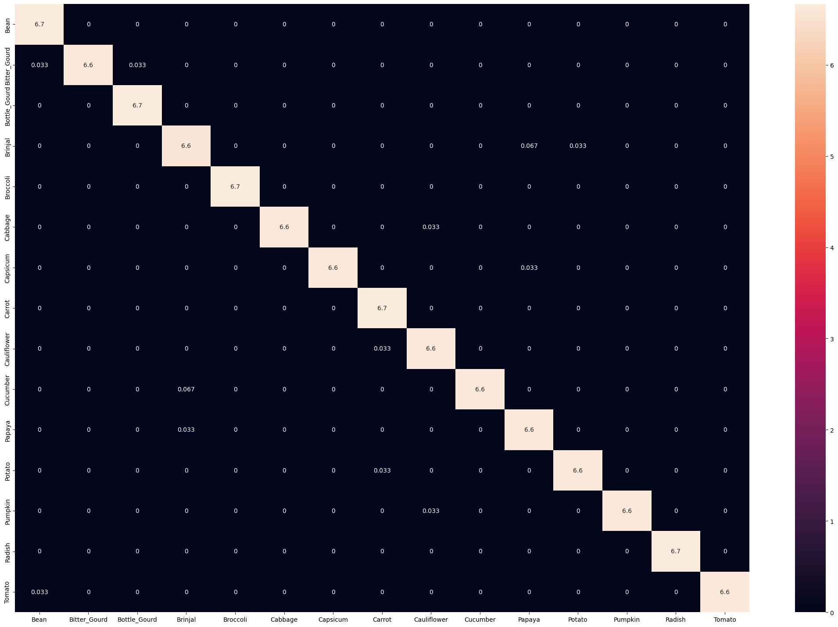

**Fig. 6. Confusion Matrix Using Heatmap of Classifiers**

## 7.2Analysis of results

## ResNet18 is the name given to the 18-layer ResNet design. It is well recognised for incorporating skip connections, commonly referred to as residual blocks, which solve the vanishing gradient problem and make it appropriate for deep networks. A completely linked classification layer makes up the final layer of the model. AlexNet is a state-of-the-art deep neural network architecture. This approach uses convolutional layers that are completely coupled. It was crucial for the widespread application of deep learning to photo classification issues. Convolutional layers are stacked, and then max-pooling layers are added to construct the VGGNet's uniform VGG11_bn enhances training stability. With fewer parameters, SqueezeNet is intended to be a small deep neural network architecture. The model is accurately maintained while being compressed using 1x1 convolutions and fire modules. A well-known aspect of DenseNet is its dense connectivity between layers. It creates feedforward connections between each layer to promote gradient flow and feature reuse. GoogleNet, also known as Inception v1, was the business that originated the concept of inception modules. It aims to be both computationally efficient and insightful. It is effective for a variety of picture categorization tasks. To balance model accuracy and processing speed, ShuffleNet employs channel shuffling and group convolutions. It performs admirably for real-time applications on hardware with limited resources.ResNeXt is a supplement to the ResNet architecture. The addition of cardinality improves the model's usability. ResNeXt50_32x4d describes the network depth and cardinality settings.

## Fig. 7. Test accuracy of all models

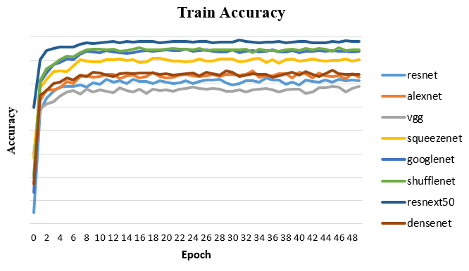

## Fig. 8. Train accuracy of all models with corresponding epoch

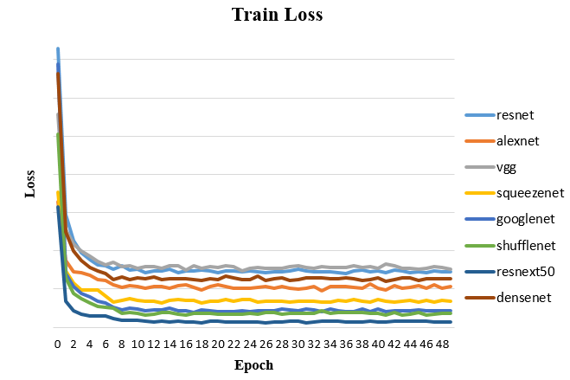

## Fig. 9. Train loss of all models with corresponding epoch

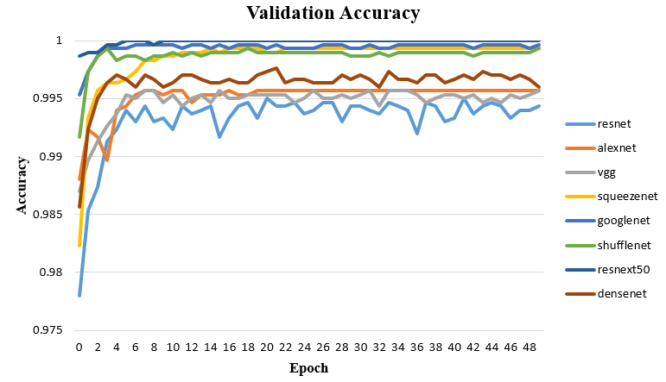

## Fig. 10. Validation accuracy of all models with corresponding epoch

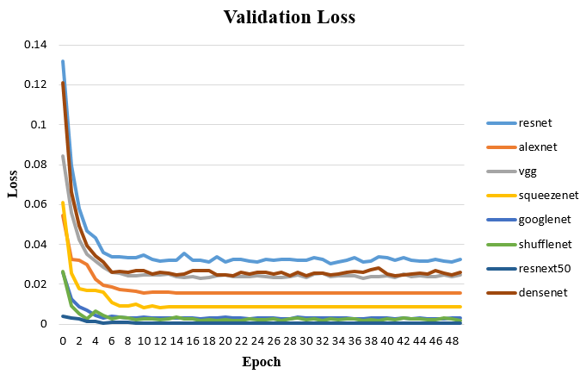

## Fig. 11. Validation loss of all models with corresponding epoch

# 8. Conclusion

Image processing is used to classify the various 15 categories of culinary vegetable images. For each of the 15 vegetable classes, a minimum of 850 pictures were painstakingly collected. As a result, the dataset used in this study is unique. To begin the categorization, the shape feature is extracted. Second, several approaches, such as Resnet, Alexnet, Vgg, Squeezenet, Googlenet, Shufflenet, Resnet50, and Densenet, were used to obtain classification accuracies. Based on these findings, the analysis was drawn using heat maps. Using the Resnet50 Classifier of the Deep Learning model, it received an accuracy of 0.999333%. The farmers will get benefits directly after the implementation of this model in-app. This will boost the farming sector, leading to a boost in the Indian economy. Through this paper, it is seen that Resnet50 classifiers performed better than any other classifier. I have used eight classifiers and analyzed their performance through accuracy. For visualization, I used a heat map, which gives us a clear view of their classifier performance. I finalized this result using hyperparameter tuning and each classifier and checked their best effect.

In the future, the Machine learning model will be applied to the same dataset of 15 different culinary vegetables to achieve higher accuracy than the best Machine learning model, and the correlation of some culinary vegetables, such as LIMA BEAN, TOMATO, POTATO, and others, will be improved through proper data analysis. Other algorithms can also be evaluated to choose the best classifier. Deep learning and other advanced methods can be utilized for severely misclassified categories. More culinary vegetable image categories can be collected for classification.

# 9. References

[1] M. Danish Toor et al., "Nutrients and Their Importance in Agriculture Crop Pro- duction: A Review," Ind. J. Pure App. Biosci, vol. 9, no. 1, pp. 1–6, 2021, doi: 10.18782/2582-2845.8527.

[2] M. K. Tripathi and D. D. Maktedar, "Detection of various categories of fruitsand vegetables through various descriptors using machine learning techniques," Int. J. Comput. Intell. Stud., vol. 10, no. 1, p. 36, 2021, doi: 10.1504/IJCISTUD- IES.2021.113819.

[3] R. Kaur, A. Jain, and S. Kumar, "Optimization classification of sunflower recog-nition through machinelearning," Mater.TodayProc.,vol.51,pp.207211,Jan. 2022, doi: 10.1016/J.MATPR.2021.05.182

[4] "Classification model for accuracy and intrusion detection using machine learningapproach [PeerJ]." https://peerj.com/articles/cs-437/ (accessed May 11, 2022).

[5]“VegetableClassification.”http://dspace.daffodilvarsity.edu.bd:8080/handle/ 123456789/564(accessed May 11, 2022).

[6] K. Padmavathi and K. Thangadurai, "Implementation of RGB and Grayscale Im-ages in Plant Leaves Disease Detection – Comparative Study," vol. 9, no. February, pp. 4–9, 2016, doi: 10.17485/ijst/2016/v9i6/77739.

[7] M. Egmont-Petersen, D. De Ridder, and H. Handels, "Image processing with neuralnet-works—a review," Pattern Recognit., vol. 35, no. 10, pp. 2279–2301, Oct. 2002, doi: 10.1016/S0031-3203(01)00178-9.

[8] M. Salvi, U. R. Acharya, F. Molinari, and K. M. Meiburger, "The impact of pre-and post-image processing techniques on deep learning frameworks: A comprehen- sive review for digital pathology image analysis," Comput. Biol. Med., vol. 128, p. 104129, Jan. 2021, doi: 10.1016/J.COMPBIOMED.2020.104129.

[9] A. Behura, "The Cluster Analysis and Feature Selection: Perspective of Machine Learning and Image Processing," Data Anal. Bioinforma., pp. 249–280, Feb. 2021, doi: 10.1002/9781119785620.CH10.

[10] A. Valikhani, A. Jaberi Jahromi, S. Pouyanfar, I. M. Mantawy, and A. Azizinamini, "Machine learning and image processing approaches for estimating concrete surface roughness using basic cameras," Comput. Civ. Infrastruct. Eng., vol. 36, no. 2, pp. 213–226, Feb. 2021, doi: 10.1111/MICE.12605.

[11] A. S. Tulshan and N. Raul, "Plant Leaf Disease Detection using Machine Learn-ing," 2019 10th Int. Conf. Comput. Commun. Netw. Technol., pp. 1–6, 2019.

[12] P. Panchal, V. C. Raman, and S. Mantri, "Plant Diseases Detection and Classification using Machine Learning Models," CSITSS 2019 - 2019 4th Int. Conf. Comput. Syst. Inf. Tech-nol. Sustain. Solut. Proc., Dec. 2019, doi: 10.1109/CSITSS47250.2019.9031029

[13] M. Jasim, J. A.-T.-2020 I. C. on, and undefined 2020, "Plant leaf diseases detection and classification using image processing and deep learning techniques," ieeexplore.ieee.org,Ac-cessed:May06,2022.[Online].Available: <https://ieeexplore.ieee.org/abstract/document/9142097/>

[14] D. Varshney, B. Babukhanwala, J. Khan, D. Saxena, and A. K. Singh, "Ma- chine Learning Techniques for Plant Disease Detection," Proc. 5th Int. Conf. Trends Electron. Informatics, ICOEI 2021, pp. 1574–1581, Jun. 2021, doi: 10.1109/ICOEI51242.2021.9453053.

[15] Deepa, N. Rashmi, and C. Shetty, "A Machine Learning Technique for Identifi- cation of Plant Diseases in Leaves," Proc. 6th Int. Conf. Inven. Comput.Technol.ICICT2021,pp.481484,Jan2021,doi:10.1109/ICICT50816.2021.935877.

[16] M. V. Madhavan, D. N. H. Thanh, A. Khamparia, S. Pande, R. Malik, and D. Gupta, "Recognition and classification of pomegranate leaves diseases by image processing andma-chine learning techniques," Comput. Mater.Contin.vol.66,no.3pp.29392955,2021,doi:10.32604/CMC.2021.01246

[17] V. S. Babu, R. S. Kumar, and R. Sunder, "A Comparative Study on Disease Detection of Plants using Machine Learning Techniques," 2021 7th Int. Conf. Adv. Comput. Commun. Syst. ICACCS 2021, pp. 1937–1941, Mar. 2021, doi: 10.1109/ICACCS51430.2021.9441844.

[18] P. Sharma, P. Hans, and S. C. Gupta, "Classification of plant leaf diseases using ma- chine learning and image preprocessing techniques," Proc. Conflu. 2020 - 10th Int. Conf. Cloud Comput. Data Sci. Eng., pp. 480–484, Jan. 2020, doi: 10.1109/CON- FLUENCE47617.2020.9057889.

[19] S. X. Wu, H. T. Wai, L. Li, and A. Scaglione, "A Review of Distributed Algorithms for Principal Component Analysis," Proc. IEEE, vol.106,no.8,pp.13211340,Aug.2018,doi:10.1109/JPROC.2018.284658.

[20] V. R. Joseph and A. Vakayil, "SPlit: An Optimal Method for Data Splitting," Technometrics,vol.2022no2,pp.166176,2021,doi:10.1080/00401706.2021.1921037/SUPPL FILE/UTCH A 1921037 SM8231.PDF.

[21] N. F. Fernandez et al., "Clustergrammer, a web-based heatmap visualization and analysis tool for high-dimensional biological data," Sci. Data 2017 41, vol. 4, no. 1, pp. 1–12, Oct. 2017, doi: 10.1038/sdata.2017.151.

[22] "Data capture and processing system to display a heat map." https://upcommons.upc.edu/handle/2117/363254 (accessed May 11, 2022).

[23] Read, J., Pfahringer, B., Holmes, G., & Frank, E. (2011). Classifier chains for multi-label classification. Machine Learning, 85(3), 333–359. doi:10.1007/s10994- 011-52565

[24] S. Sachar and A. Kumar, "Survey of feature extraction and classification tech- niques to identify plant through leaves," Expert Syst. Appl., p. 114181, 2020, doi: 10.1016/j.eswa.2020.114181.

[25] K. O'Shea and R. Nash, "An introduction to convolutional neural networks," *arXiv preprint arXiv:1511.08458*, 2015.

[26] H. Gholamalinezhad and H. Khosravi, "Pooling methods in deep neural networks, a review," *arXiv preprint arXiv:2009.07485*, 2020.

[27] S. S. Basha, S. R. Dubey, V. Pulabaigari, and S. Mukherjee, "Impact of fully connected layers on performance of convolutional neural networks for image classifica- tion," *Neurocomputing*, vol. 378, pp. 112–119, 2020.

[28] A. F. Agarap, "Deep learning using rectified linear units (relu)," *arXiv preprint arXiv:1803.08375*, 2018.

[29] H. Li, R. Zhao, and X. Wang, "Highly efficient forward and backward propaga- tion of convolutional neural networks for pixelwise classification," *arXiv preprint arXiv:1412.4526*, 2014.